|  |
| --- |
| 12-02-2018 / Week 2 / Eolas, Room 002 / Issued by: Sean Kelly |

|  |
| --- |
| Meeting Minutes |

# Attending

Ruiqi Li (17251911), Sean Kelly(17185530), Lorraine Mc Gonigle(63349098), Kevin Brendan O’Kelly(67551321)

## Announcements

Task 1: Record User Story Cards

Task 2: Generate digital versions of the user story cards

## Discussion

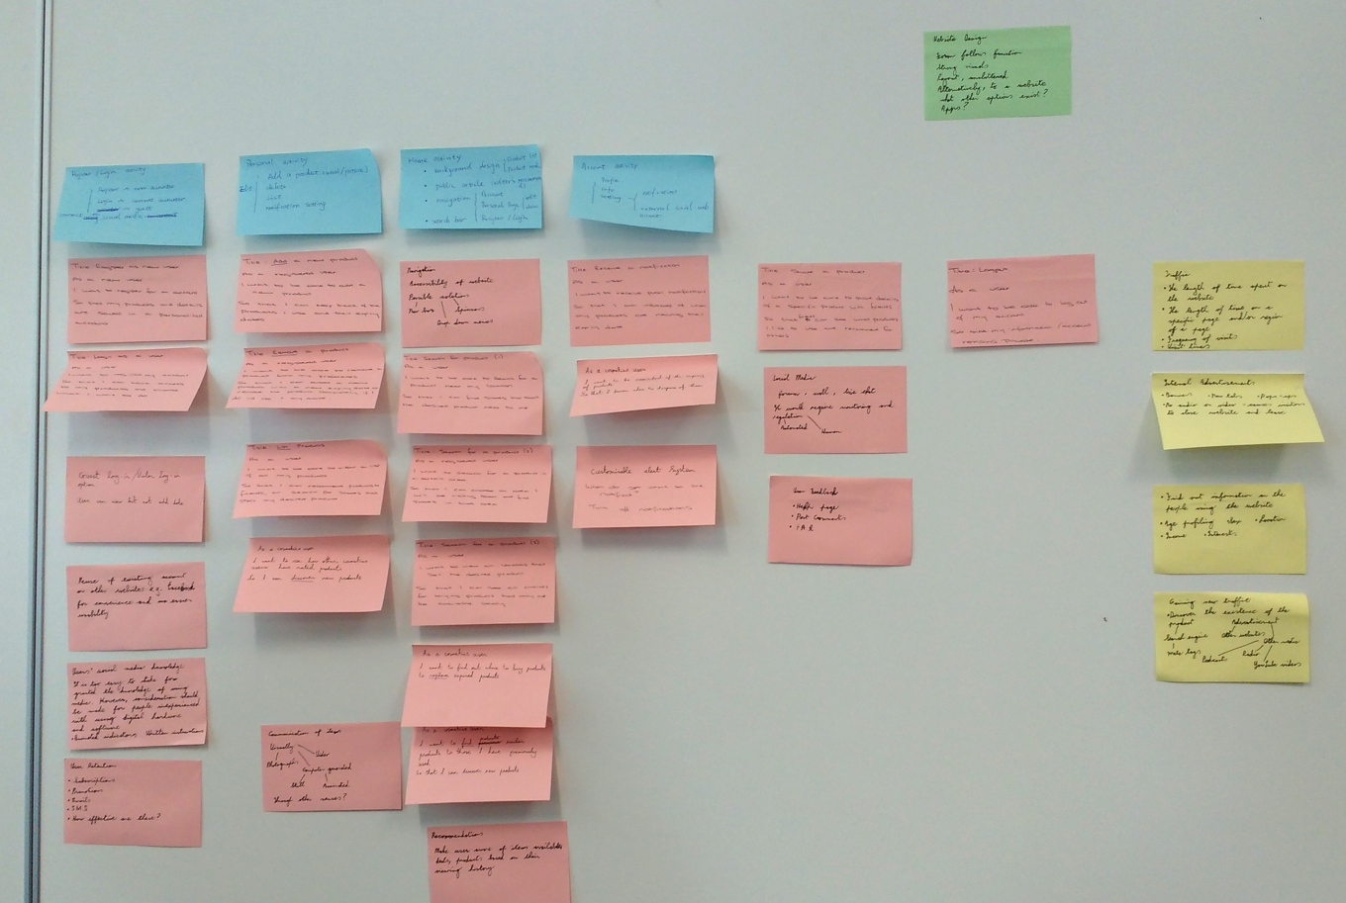  
Fig 1: User-Story first attempt

Rather than working on the computer, we decided to work on the lab wall to allow each us all to see the layout easier than on a limited sized computer screen. We had the previous week decided to work separately so as not influence each other’s through processes. Once the lab began we combined our work, discussed what was missing, where to place each post-it and consulted with one of the demonstrators and our lecturer, Dr. Casey. Before the feedback, the resulting layout was as seen in figure 1 below. Having through we were on the right track, we proceeded in creating a timetable to ascertain the tasks required and their time frames in order to delegate the workload between the team.

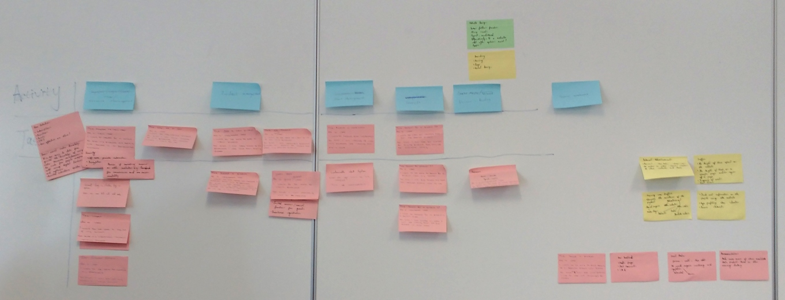  
Fig 2: User-Story second attempt

After consultation, it became apparent we got the layout wrong, although Lorraine’s post-its approached the user story correctly. Most of the post-its used in the second layout were hers’. However, we kept as much information as possible from all the post-its to aid in further development to come.

Rachel took the initiative in creating a digital version of the user story layout as shown in figure 3, from which Sean made a full version using Inkscape shown in figure 4, completed the following day.

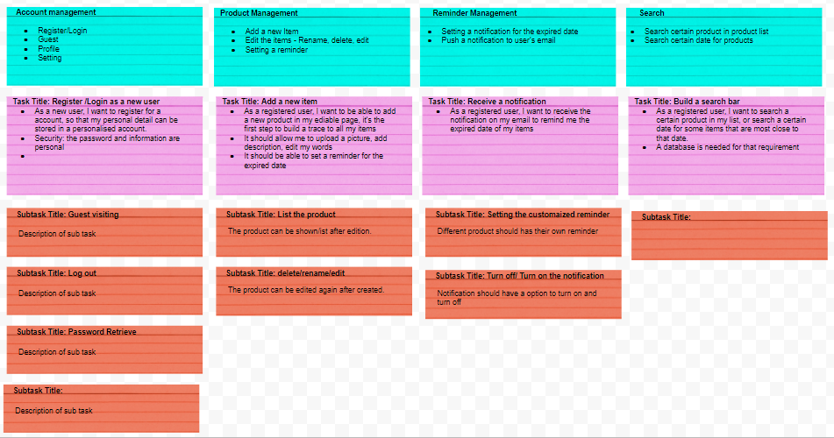  
Fig 3: Google Docs Version

Poker cards were printed out and prepared for use Monday, but we decided afterwards to leave it for a meeting during the week or the following Monday. Kevin was sketching out logo designed casually on his notepad, we decided to give him the task of designing the brand logo. Lorraine had already made a html layout with jQuery the previous week to enable us to learn how to use the languages required for web development.

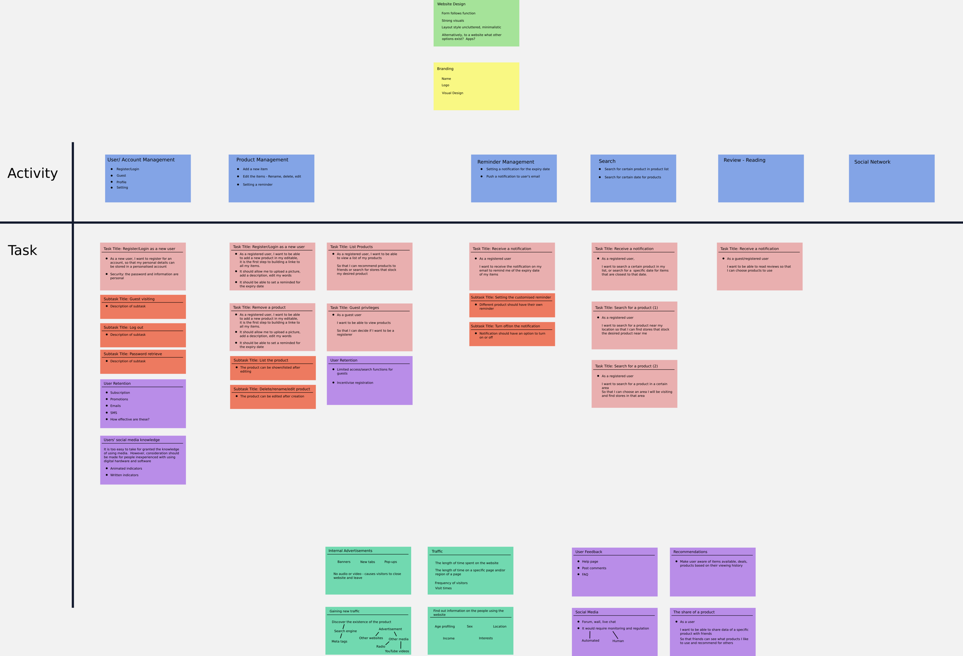  
Fig4: User-Story in SVG Format

## Conclusion

Lorraine especially and Rachel figured out how user stories worked straight away. Sean got caught up thinking about the technical aspects, while the mindset should be oriented around the user and trying to think about their needs and user experience. Regardless, in the end a user story was created that helped give a clearer vision of the task ahead, even if our knowledge of JS was limited at this time.